KU Directory
Database: https://hr.ku.edu

Employee
Tile: Personal Data>KU Directory Info
Choose One: On-Site: Designation of working at a building owned or leased by KU
Hybrid: Work both On-Site and Remote
If hybrid indicate the average hours per week that you are working On-Site
Fully Remote: Not working at a building owned or leased by KU (home etc.)
If working in Kansas, please select the correct Kansas county.
If working outside of Kansas, please select the state.
The work type location chosen will change the Location Information. One location for each position held will need to be indicated as primary. If you are hybrid and split 50/50 default the primary to the On-Site location.

If you cannot find your value for Location, please email hrpay@ku.edu, and include the missing value.
Hybrid example below:

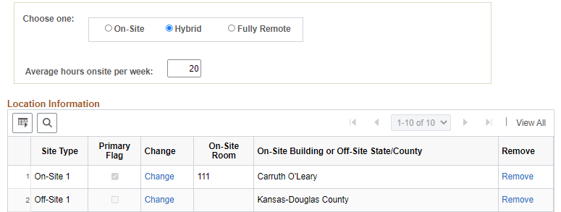

If an on-site room is not available, please email hrpay@ku.edu with the missing building and/or room.

Managers
Tile: My Team
Supervisors have access to their employee’s directory data under the My Team Tile, using the related actions (blue circle) by the employee’s name. Select the Job and Personal Information option.

