Reporting Affordable Care Act (ACA) Hours – Salaried (Exempt) Students

Database: https://hr.ku.edu
Who should report ACA Hours: See details at Graduate Salaried Student ACA reporting.
Tile: Time and Absence>Report Time
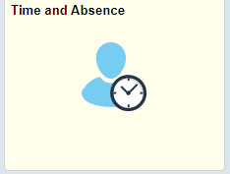
- If you hold multiple jobs, you will need to select the correct job from the drop down and select Apply before recording your punch.
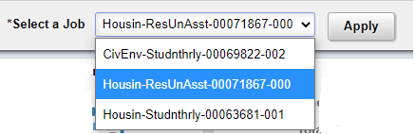

- Select Date(s):
  - Click on the Report Time button. Today’s date is the default. To report hours on a different date, select the date words at the top and a calendar will display to choose a different date.
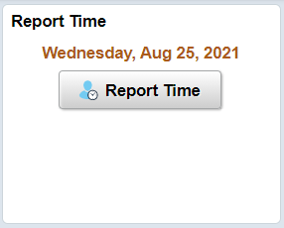
- Select the Time Reporting Code of ACA-AffordabilityCareAct-Rptg only.
- Type in total hours worked for the day in quarter hour increments.
- Submit.
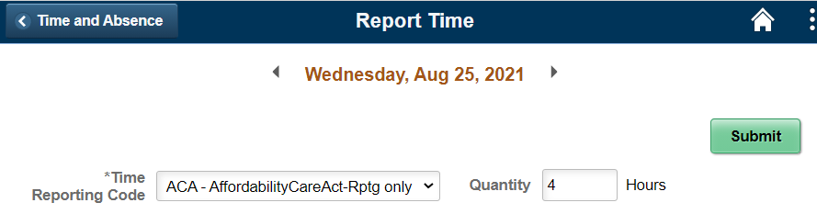
Sign Out securely. Select the 3 vertical dots on right side of the banner bar and select Sign Out.

