Delegate Transactions
Database: https://hr.ku.edu
Tiles: Delegations>Create Delegation Request
Delegation is when a supervisor assigns a proxy to act on their behalf. The proxy is assigned to a transaction type. The supervisor (delegator) will still retain access rights. Absence emails will be sent to both the supervisor and proxy. An outlook rule may be created if the supervisor wishes to not read the emails. Delegation does not relieve the supervisor of their oversight responsibility.
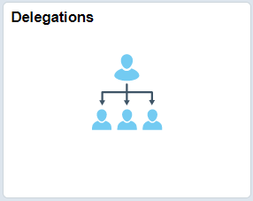

Tiles: Delegations>Create Delegation Request
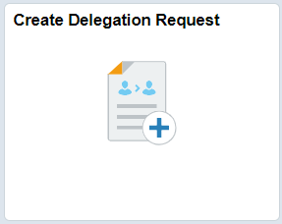
- Delegation Dates:
  - Start Date (required)
    - Future dates are acceptable but past dates are not.
    - If future dated, delegation begins shortly after midnight.
  - End Dates (optional)
    - If end date is selected, delegation ends at midnight of the End Date.
  - Comments are required. (Can be brief - just need a value.)
  - Select Next.
- Delegates:
  - Select the Delegate(s). The page displays suggested persons in your hierarchy which you may select, or you may select any other active employee by using the Add Delegate button.
    - If you select the Add Delegate button, then choose the lookup icon, expand Search Criteria and type in last and/or first name and click Search.
    - Select the name of the person, then click Done.
    - The delegate you added is at the bottom of the list already checked.
    - Select Next.

- Transactions:
  - Select the Transaction(s) to delegate, then select Next.
Description of Transaction Types
- Absence Cancelation – access to approve absence cancelations
- Manage Approve Payable Time – access to approve payable time
- Manage Report Time Fluid – access to report time
- Manager Abs Cancelation Fluid – access to cancel an absence
- Manager Absence Approve – access to approve absences
- Manager Absence Balance Fluid – access to view absence balances
- Manager Absence History Fluid – access to view absence requests
- Manager Absence Request Fluid – access to request an absence
- Review and Submit:
  - Review summary and if correct select Submit.
  - Once submitted the Delegate will be sent an email to accept the delegation.
Tiles: Delegations>My Delegated Authorities
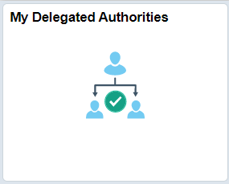
Accept Delegation
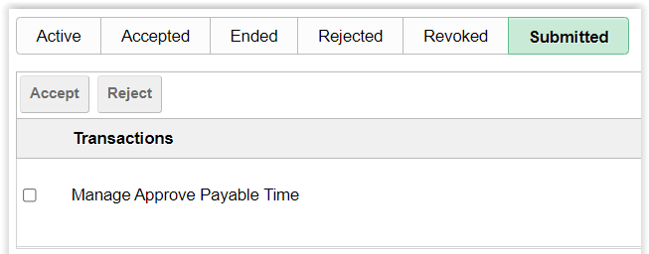
- My Delegated Authorities tile opens to Submitted transactions by default.
- Check the box next to transaction(s) delegated to you and click Accept button.
- If the delegation begings immediately, then once accepted you will need to log out of HR/Pay. When you log back in, you will have security access to page(s) for those transaction(s).
- If the delegation is future dated, then you will not have security access to the pages until that date.
  - Future dated accepted delegations will show up on the Accepted tab.
  - Once the future date is reached, the delegation will show under the Active tab
- Delelgation tabs:
  - Active – delegations to you that are currently active, either submitted or accepted
  - Accepted – delegations you have accepted
    - Delegations may also be accepted in the Approvals Tile.
  - Ended – delegations that have expired
  - Rejected – delegations that you rejected (did not accept)
  - Revoked – delegations that the delegator ended
  - Submitted – delegations pending your acceptance or rejection

Tiles: Delegations>My Delegates
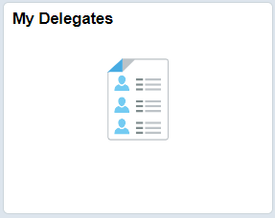
Revoke a Delegation
- My Delegates tile opens to Active transactions by default.
- Check the box next to transaction(s) you want to cancel and click Revoke button.

Sign Out securely. Select 3 dots on right side of banner tool bar and select Sign Out.

