My Team – Manager
Database: https://hr.ku.edu
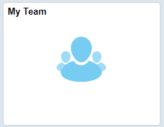
This tile displays all employees under your supervisory hierarchy with drill down capability. This tile allows viewing to titles, compensation, and leave balances. The related actions will allow you to drill down to see compensation history, email and allow updates to the KU Directory information, etc. (diretory building codes)
Click on icon to drill down.
There are Related Actions (drop down navigation to pages) if you use the green circle displayed on many pages.
Related Action primary menu. 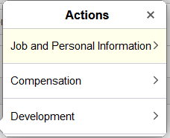

Sign Out securely. Select 3 vertical dots on top right side of banner bar and select Sign Out.

