Team Time & Absence – Manager
Database: https://hr.ku.edu
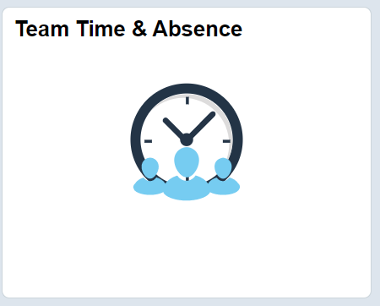
This tile displays a collection of pages on the left-hand side. Options are displayed based on security and type of employees reporting to you. Each item listed below is described in this document in the order listed.
Time Reviewers (shared service center staff, budget managers and personnel related staff) will use this Manager tile to access limited areas and actions in which they have responsibility.
Display Options may vary based on types of employee reporting to you.
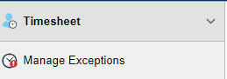
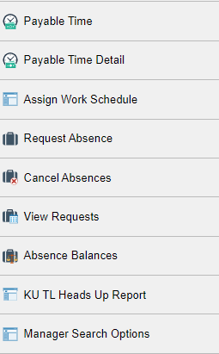

There are Related Actions (drop down navigation to pages) if you use the green circle displayed on many pages.
Manager Search Options page is a way to reduce the data returned or create a prompt. It is advisable for those with broader access than their own direct reports to set the Manager Search Options (see last menu item and is covered at the end of the document).
The process described below is used for viewing, entering, or editing an employee’s time.
For a better display use on a regular sized device as this is in a weekly format.
Clock time entering or editing by the manager role is only available on a regular sized device.

- Timesheet > Enter Time
  - Get Employees or Filter is used to narrow down employee selection, select employee, page opens.
  - Dates and arrows on the middle top of the page allows for moving between dates.
  - Return to Select Employee top left allows moving between employees.
  - + and – at end of row is for adding or deleting rows.
  - If changes are made, add comments in call outs by the day, preferably pasting in the email from the employee to provide documentation for audit.

Example of Clock Timesheet grid. (Row is broken into 2 screenshots.)
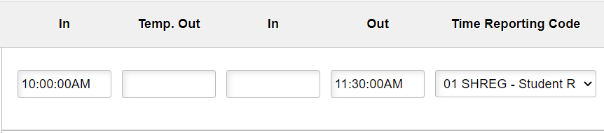

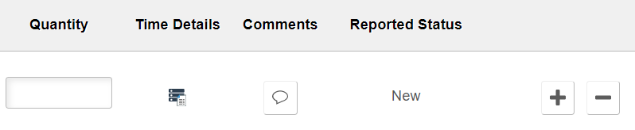

Example of Elapsed Timesheet grid (Row is broken into 2 screenshots.)
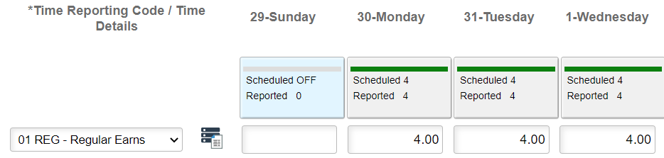
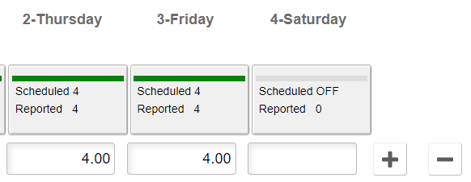
- Timesheet > Time Summary
  - View comparison of scheduled time and reported/payable time.
  - Get Employees or Filter is used to narrow down employee selection, select employee, page opens.

- Manage Exceptions
  - This will display if an employee has a time reporting exception; no returned data means no exceptions.
  - Select Funnel to refine selection of employees.
  - Exceptions are created from the reported time data not passing the time and labor rules during the time administration process.
    - Exceptions must be corrected timely as the employee cannot be paid for this time until the data passes the time administration process.
    - The most common errors are an employee missing a clock/punch or an incorrect punch type.
    - Changes will need to be made in the timesheet. (See Enter Time.)
  - If the employee uses a web clock, the employee is not able to modify the timesheet.
    - Supervisor or time reviewers will need to modify the punch timesheet.
    - Documentation should be added to the comments/call out.
  - Elapsed time reporters should modify their own time.
    - Supervisors and time reviewers have access to update timesheets if needed (rare).
    - Documentation should be added to the comments/call out.
  - When time administration runs again, the process will pick up the modifications to create new Payable Time for approval.
    - If approved time was modified, the time administration process will create negatives to remove the original approvals and create new total payable hours to approve.
    - The negative hours must be approved, or the employee will be overpaid.
  - Do not enter 0 or negative hours.

- Payable Time
  - Shows Current Payable Time, Past Payable Time, and Paid Absences based on date ranges.
  - Get Employees or Filter is used to narrow down employee selection, select employee, page opens.
  - No option to Choose by Delegate (if applicable).
  - Select employee, if needed, change the default dates.
  - There are 2 tabs Summary and Detail (see Payable Time Detail on left menu to see approval information.)

- Payable Time Detail
  - Shows Current Payable Time, Past Payable Time, and Paid Absences based on date ranges.
  - If Proxy, you will need to pick your own or Delegate’s employees.
  - Select Get Employees or use Employee Selection Criteria.
  - If needed, change the default dates, refresh with green arrows.
  - This view allows you to click on the Status to see the workflow including the approver and date of approval.

- Assign Work Schedule – Used for Absence, Holiday hours, if eligible and hours displays.
  - Select Employee by Name or Employee ID.
  - Insert a row by using the + on the end of the current row.
  - Add the Effective Date of the new schedule.
    - Generally, the start date is the beginning of a payroll period.
  - Do not enter an effective date in a prior payroll period unless directed by Human Resource Management (HRM). This impacts past absences and holidays. You may enter future dates.
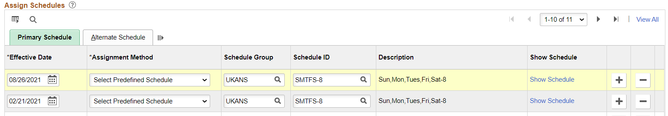
  - Schedule ID – use the magnify glass icon to search.
  - Change the search parameter to “contains” and include text to find schedule.
  - Select the schedule and it will populate on the page.
  - Select the Save button (bottom left).
  - If you cannot find the correct schedule, email hrpay@ku.edu or 785/864-0600.

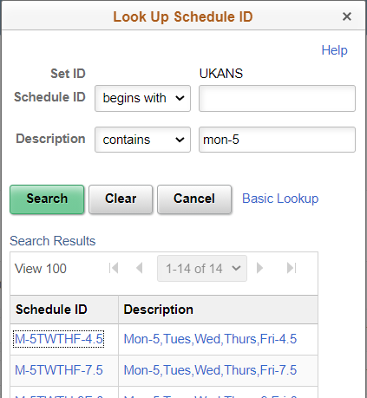

- Request Absence
  - All direct reports may show in Absence pages even if they are not eligible for an absence.
  - Select Employee from list displayed or use Search Options.
  - You may submit an Absence for any employee reporting up to you.
  - It is advisable to enter in comments or email for audit.
  - The page is the same as the employee Absence Request page.
  - The employee and supervisor will receive an email notification.

- Cancel Absences
  - Select Employee from list displayed or use Search Options.
  - Click on the Absence selected to cancel.
  - Select the green Cancel Absence button on the top right.
  - You will be prompted to answer Yes to continue or No.
  - The employee and supervisor will receive an email notification.
- View Requests (Absence)
  - Select Employee from list displayed or use Search Options.
  - You may use Filters to view absences for other dates, types, or statuses.
  - Click on the absence to view details.

- Absence Balances
  - Select Employee or use Search Options.
  - Click on the employee to view details.

- KU TL Heads Up Report (4 Reports)
  - Create a Run Control ID (unique to you and without any spaces); you can reuse once added.
  - Company: KUL
  - From Department and To Department: Enter in the lowest and highest Department numbers (they may be the same value).
  - Security will restrict you to those departments or employees to which you have access.
  - There are 4 reports; check the one(s) you want.
    - TL OK to Pay –Payable Time Approved
    - TL Not OK to Pay –Payable Time Not Approved and Exceptions
    - Absence Request Approved (current payroll period only)
    - Absence Request Not Approved
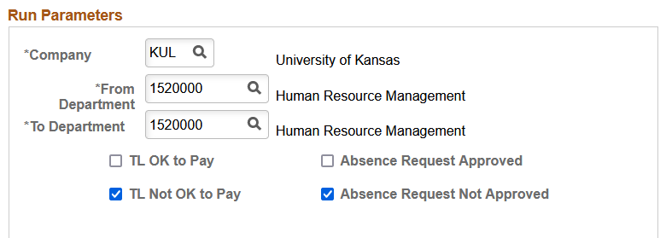
  - Select Run
  - Select OK on the Process Scheduler Request page.
  - You may monitor by looking at the Process Monitor (link top of page)
  - Process Name = JTL001
  - When Run Status=Success and Distribution Status = Posted the process has completed.
  - Select Details hyperlink.
  - Select View Log/Trace hyperlink.
  - Report(s) will be listed and are the .csv files
- Manager Search Options
  - Allows user to set default when calling up Time.
    - This is strongly recommended for time reviewers.
  - A recommended set up for time reviewers is below.
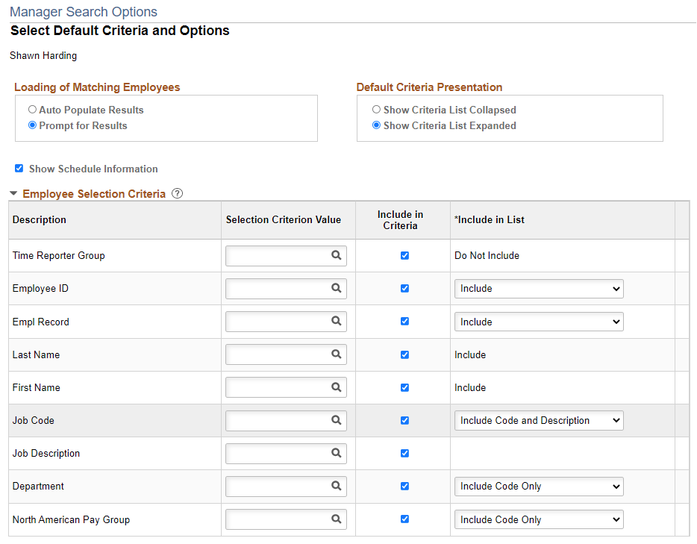

  - Other Reference Materials are located humanresources.ku.edu, under Time and Pay.

  - Sign Out securely. Select 3 vertical dots on top right side of banner bar and select Sign Out.

