Guide to Time and Absence Reporting

- The University’s designated work week is Sunday 12:00 am to Saturday 11:59 pm.
- No Time or Absence reporting is to be done or kept outside of HR/Pay. HR/Pay is the University’s system for all Time and Absence reporting.
- Employee and Supervisors are not authorized to keep track of any hours worked or absences taken outside of the University’s HR/Pay system.
- Time and Absences must be submitted accurately, actual day and total time/hours.
- Time and Absence approvals should not be withheld for any reason if they are true and accurate
- Time and Absences are to be submitted by the end of each work week. More frequent reporting may be designated by the supervisor or employee choice.
- Reported time is not available for the Supervisor to approve until the Time Administration process has run on time reported. This process runs twice a day.
- Time and Absences must be approved by the biweekly deadline – generally the deadline is Monday after the end of the payroll period.
- Hourly
  - Federal and State Law requires hourly employees must be compensated for all hours worked (authorized or not).
  - Hourly employees are required to use the time method assigned by Human Resource Management – HR/Pay system team.
  - Hourly employees will be paid in .25 increments for hours worked and absences.
  - KU has two types of time reporters:
    - Clock – Use the Web Clock to report time worked. This is assigned to temporary hourlies and premium pay employees. (premium pay –call back, standby, shift eligibility)
    - Elapsed-Use the timesheet and record daily total hours.
  - Clock time reporting will be rounded by the Time Administration process.
  - Elapsed time reporters are to report time in .25 increments in the timesheet.
  - Rounding page: http://humanresources.ku.edu/time-rounding-chart.
  - Absences are to be reported in .25 increments.
  - Hourly employees are to seek supervisor approval in advance to work outside their designated work schedule.
  - Employees working 6 hours are required to have a minimum 30-minute unpaid meal break.
  - There are only two HRM granted exceptions: Public Safety Officers and Steam Monitors as they must be on alert their entire working schedule.
  - Employees are not allowed to report absences in addition to work time that exceeds their scheduled hours.
  - Time Reporting Codes are used to correctly calculate pay and compensatory balances.
  - Employees do not earn compensatory time until the worked hours and holiday credit are over 40 hours in the work week, per the Federal Labor Standards Act (FLSA).
  - Absences are displayed on the timesheet from the Absence Module, consult the Absence View Request Tile for accuracy.
  - Only enter hours greater than 0. Do not enter 0 or negative hours.
  - All hours worked must be compensated. They may be paid or may add to compensatory balances.
- Employees are responsible for alerting their supervisor/designee if there are any inaccurate or missed times or absences.
  - Documentation: Time reviewers should only make changes with proper documentation and pasted into the comments. This is also strongly suggested for supervisors.
  - Documentation: It is strongly suggested if the supervisor is making changes, documentation be included in the timesheet comments section. This is required for time reviewers making changes.
- Graduate students may report Affordable Care Hours. http://humanresources.ku.edu/sites/humanresources.drupal.ku.edu/files/docs/Graduate%20Student%20Time%20Reporting%20Brochure%20for%20the%20ACA_FINAL.pdf
- Time Reporting Codes (TRC)
  - The HR/Pay Time and Absence Information Guide will have a listing of all Time Reporting Codes. Time Reporting Codes assist in the calculation of hours and pay. http://humanresources.ku.edu/sites/humanresources.drupal.ku.edu/files/docs/Time_and_Absence.pdf
    - REG-Regular (non-student) or SHREG-Regular (student) for all regular hours worked
    - If a time reporting code is not included, the system will assume it is regular worked time.
- Time Administration
  - System process that must run before Reported Time (timesheet) becomes Payable Time.
  - Process runs twice a day.
  - Process applies rounding for the clock times.
  - Process applies the configured rules and may create time Exceptions.
  - There may be several reasons a supervisors cannot view their employee’s time to approve.
    - The employee has not submitted their timesheet for approval,
    - The employee has submitted the time, but Time Admin has not run or is currently processing,
    - There is an exception to the time reported that must be corrected,
    - The employee has not signed into HR/Pay which impacts workflow, or
    - The employee has a different supervisor designated in HR/Pay.
  - The time admin process will pick up the changed data, reprocess and creates new payable time.
  - Negatives generated by Time Administration must also be approved or the employee will be overpaid.
- Absence Reporting
  - Absence request for hourly (non-exempt) employees taking less than a full or half day, will indicate the hours taken. (Leave request are to be in quarter hour increments (.00, .25, .50, .75)
  - Absence request for salaried (exempt) employees only use partial days for ½ days or in certain circumstances (i.e., HRM approved family medical leave).
  - Supervisors may submit absences on behalf of their employee. This should only be in cases in which the employee is unable to submit.
  - Absences are displayed on the timesheet from the Absence Module; consult the Absence View Request Tile for accuracy.
- Absence Payouts
  - The HR/Pay system will generate the following payouts automatically:
    - Compensatory Time balance that exceeds 90 hours (coded CTPPO-Comp Time Payout).
      - Cost is charged to the employee’s funding source.
    - Compensatory Time balance is paid out when an employee changes from hourly (non-exempt) to salaried (exempt).
      - Cost is charged to the employee’s funding source.
    - Compensatory Time and Holiday Comp Time balances are paid out when an employee changes departments or upon termination from the University.
      - Cost is charged to the employee’s funding source.
    - Vacation upon termination if the employee is not taking a job at KU or another state agency. http://humanresources.ku.edu/vacation-leave
      - Cost is covered by central KU funds that have been collected.
    - Vacation when the employee changes from a fiscal year employee to an academic year employee at KU. http://humanresources.ku.edu/vacation-leave
      - Cost is covered by central KU funds that have been collected.
    - Vacation upon retirement. http://humanresources.ku.edu/vacation-leave
      - Cost is covered by central State of Kansas funds that have been collected.
    - Sick leave is paid upon retirement based on the Regent’s policy: http://humanresources.ku.edu/sick-leave
      - Cost is covered by central State of Kansas funds that have been collected.
  - If an employee or department wishes to have either compensatory time balances paid out in full or in part outside the system generated payouts, the supervisor will need to secure budgetary approval (based on hierarchy). Once approved, the employee creates an Absence Request payout.
    - Cost is charged to the employee’s funding source.
- Working Additional Hours Examples
  - Working extra hours impact.
  - Regular employees earn compensatory time when the worked hours and holiday credit are over 40 hours in the work week.
  - Temporary employees are not eligible to earn compensatory time or holiday credit, all hours worked are paid.
  - Holiday Credit for KU counts towards the worked week hours (40 hours Fair Labor Standards Act (FLSA) limit).
  - HR/Pay system calculates whether additional time worked is paid or accrues compensatory time.
  - A regular employee and supervisor may agree after the fact to reduce planned leave usage of vacation, discretionary day, or compensatory time (both types), (but not sick), if the employee worked over their scheduled hours in the same work week to avoid additional cash costs.

Example A: Regular employee worked 44 hours in a work week
 | S | M | T | W | R | F | S | Total
Regular | 4 | 8 | 8 | 8 | 8 | 8 |  | 44
Hours Paid |  |  |  |  |  |  |  | 40
Compensatory Time 4 X 1.5 |  |  |  |  |  |  |  | 6

Example B: Regular employee worked extra hours but also took an absence the same work week. If the total hours and absences exceed 40 but the worked time (+ any holiday credit) is 40 or less, the additional hours over 40 is paid as regular time which increases the “cash” expense to the department.
 | S | M | T | W | R | F | S | Total
Regular | 4 | 8 | 8 | 8 |  |  |  | 28
Holiday Credit |  |  |  |  |  | 8 |  | 8
Absence |  |  |  |  | 8 |  |  | 8
Total Paid |  |  |  |  |  |  |  | 44

Example C: supervisor is to approve additional hours worked and absence request and may take into consideration additional costs as a factor in approving.
 | S | M | T | W | R | F | S | Total
Regular | 4 | 8 | 8 | 8 |  |  |  | 28
Holiday Credit |  |  |  |  |  | 8 |  | 8
Absence |  |  |  |  | 4 |  |  | 4
Total Paid |  |  |  |  |  |  |  | 40

- Holidays
  - If the employee was not scheduled to work on the holiday but the employee is eligible for the holiday, the process will load the holiday on the previously scheduled workday if it is in the same week. If the previously scheduled day is not in the same workweek, the holiday is loaded on the next scheduled workday after the recognized holiday.
  - Holidays are moveable. We strongly encourage the employee to take the holiday in the same week if possible or the same payroll period.
  - For those who work on the official and recognized holiday, the holiday may be moved accordingly (See Holiday Guide.) Please refer to the Guide for Eligibility of Holidays: www.humanresources.ku.edu/files/documents/benefits/Holiday_report_guide.pdf.
  - Holiday Listing: http://humanresources.ku.edu/holiday-listing.
  - Holiday and Holiday Compensatory Policy: https://policy.ku.edu/human-resources/holiday-policy.
  - HOLHR -Holiday Credit 1.0 – this is to pay the eligible employee for the holiday.
    - Responsibility for reporting: HR/Pay Team loads 4 weeks in advance.,
    - Holidays may have to be removed by the supervisor or time reviewer if the employee is ineligible (e.g., not in full pay status the workday before or after the holiday.)
      - Modifications to elapsed time reporters are done by the employee, supervisor, or time reviewers.
      - Modifications for clock employees are done by the supervisor or time reviewers.
  - Eligible employees may earn Holiday Compensatory Time (Holiday Comp Time) if required to work on a Holiday.
  - If a non-exempt employee works the holiday, it is reported in the timesheet as REG.
  - If an exempt employee works on holiday, personnel related staff or shared service center staff will collect a departmental list and provide to the HR/Pay Team to manually add to balance.
Example D: Holiday Credit – showing 2 days as a reminder to add a row for the rest of the week-elapsed reporter, employee did not work the holiday.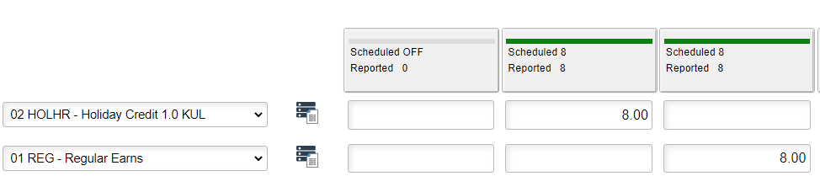
Example E: Holiday Credit (clock reporter timesheet)
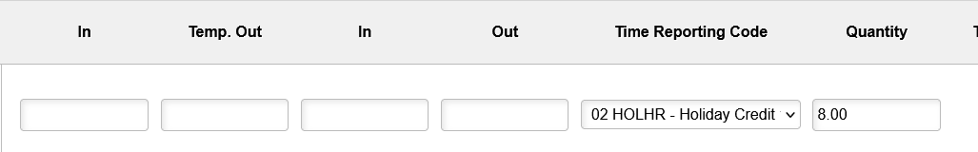

  - Holiday Compensatory Time will be calculated by the system when REG hours are reported on the same day as the HOLHR. The codes used together will add holiday compensation time for the hours the employee was required to work on the holiday. (This is the default option.)
    - This will require 2 rows in the timesheet, 1 row for each code.
    - Responsibility for reporting: employee.
      - Modifications to elapsed time reporters should be done by the employee, but the supervisor and time reviewer have access.
      - Modifications for clock employees are done by the supervisor or time reviewer.

Example F: Holiday Credit-employee worked the holiday and earning compensatory time - elapsed reporter
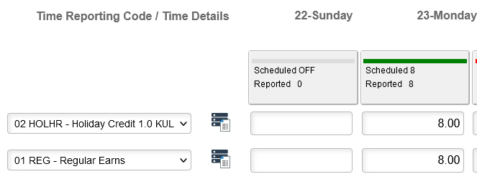

Example G: Holiday Credit-employee worked the holiday and earning compensatory time - clock reporter
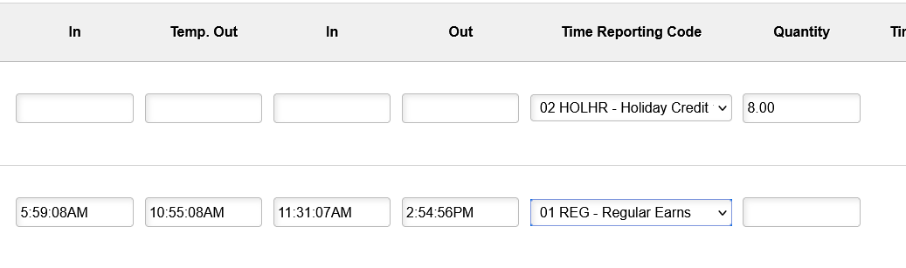
  - HDP-Holiday Pay 1.5 when used along with HOLHR, will provide additional holiday pay for the eligible employee who was required to work on the holiday and has approval to be paid instead of earning holiday compensatory time.
    - This requires department/area budgetary approval and is the exception vs the rule.
    - This will require 2 rows in the timesheet, 1 row for each code.
    - Responsibility for reporting: employee.
      - Modifications to elapsed time reporters should be done by the employee, but the supervisor and time reviewer have access.
      - Modifications for clock employees are done by the supervisor or time reviewer.

Example H: Holiday Credit-employee worked the holiday and is receiving holiday pay- showing 2 days as a reminder to add a row for the rest of the week- elapsed reporter
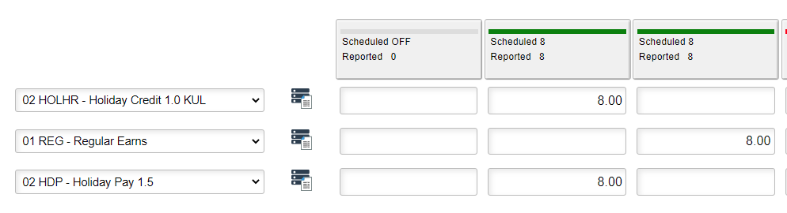
Example I: Holiday Credit-employee worked the holiday and is receiving holiday pay - clock reporter

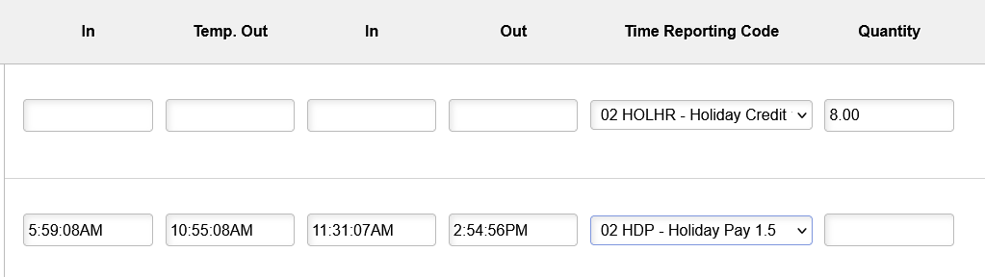

- Inclement Weather IWN
  - IWN-Inclement Weather Leave – Use when inclement weather is officially declared by the University or campus site, based on the qualifications stated in the policy. On campus only non-essential designated hourly employees will need to add the inclement weather Time Reporting Code to be paid for the time missed based on their regular work schedule
  - The Governor’s proclamations do not apply to KU as the Governor does not have jurisdiction over Regent’s agencies.
  - Inclement weather cannot be used outside the declared timeframe.
  - If a regular employee who is not designated weather essential works during the declaration period, the employee would not report any Inclement Weather.
  - If a regular on campus employee who is not designated weather essential works during part of this timeframe, the employee would only report the time missed under the Inclement Weather time reporting code.
  - If a regular employee who is not designated weather essential works their full scheduled hours for the day, the employee would not report any Inclement Weather.
  - An employee must be scheduled and planned to be at work to be eligible for inclement weather (not on leave). See Inclement Weather Time & Leave Reporting Guidelines: https://humanresources.ku.edu/document/inclement-weather-reporting-details-document.
  - Responsibility for reporting: employee for elapsed time reporter; the supervisor or time reviewers for clock employees.
  - Designated inclement weather essential/emergency personnel who are required to work on campus locations may earn compensatory time at hour for hour.

Example J: 1-hour inclement weather delay, on-campus, not weather essential and did not work. (elapsed reporter).
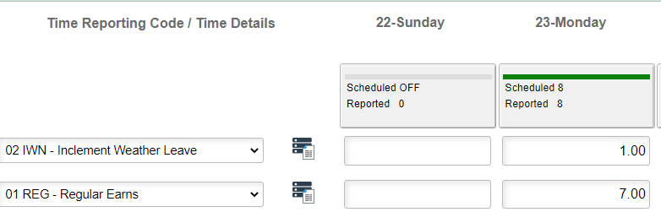
Example K: 1-hour inclement weather delay, on-campus, not weather essential and did not work. (clock reporter).
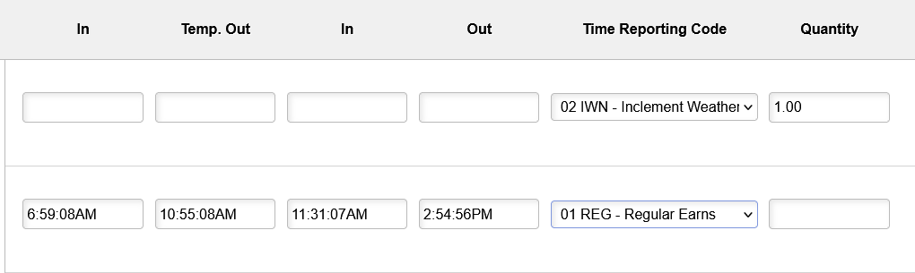
  - CM1-ClosurePosDesgntd 1XCompEarned - Employees who are required to be at the on-campus worksite during the declaration and are designated to be weather essential are eligible to receive Straight Hour for Hour Compensatory Time and would report using the TRC of CM1-Comp Time Earned (1.0) for time worked during the designated period.
  - Responsibility for reporting: employee for elapsed time reporter; the supervisor or time reviewers for clock employees.
  - Example: 1-hour inclement weather delay, on-campus employee; weather essential, worked. (elapsed reporter)

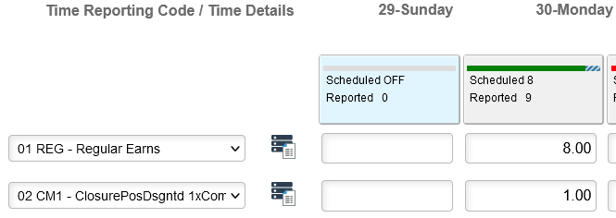
Example L: 1-hour inclement weather delay, on-campus employee; weather essential, worked-clock reporter
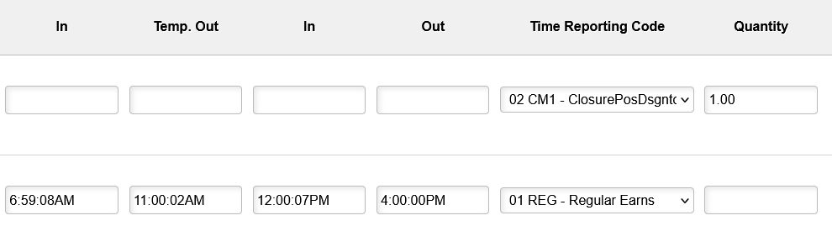
- VTN-Voting 2 hr max -Hourly regular employee.
  - Voting: https://humanresources.ku.edu/voting
  - Responsibility for reporting: employee for elapsed time reporter; the supervisor or time reviewers for clock employees.

Example M: 1.25 hour used for Voting. (elapsed reporter)
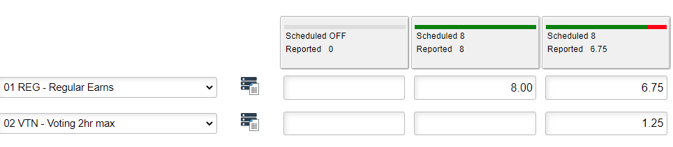

Example N: 1.00 hour used for Voting. (clock reporter)

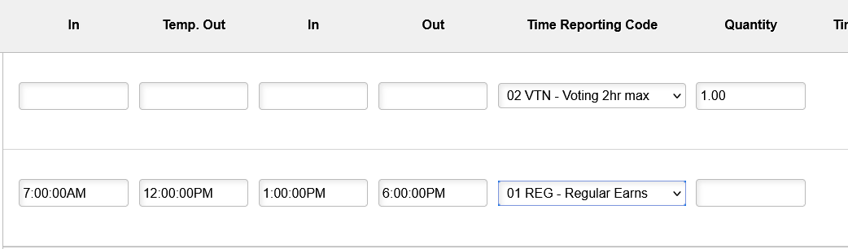

- Leave Without Pay
  - Salaried employees use Absence to report leave without pay.
  - Regular hourly employee who does not work or use an absence to cover scheduled time.
  - Responsibility for reporting: employee for elapsed time reporter; the supervisor or time reviewers for clock employees.
  - The leave without pay non-exempt code is a reporting code only, does not subtract from time or an absence reported, and the hours will show in the paycheck.
  - This is needed to fulfill our requirements for the Affordable Care Act as well as to track an employee’s time off that is unpaid. The codes are not available for temporary staff (which includes students.)
  - Hours worked and absences taken in combination with leave without pay reporting should not exceed the employee’s scheduled hours for the reporting day.
  - There are 2 codes: a) LWPN=Leave without Pay for Non-Exempt and b) LWPNF=Leave without Pay for Non-Exempt-FMLA. The FMLA code is only used if HR has approved the time to be designated under the Family Medical Leave Act (FMLA).
  - Total non-paid hours by each day in quarter hour increments should be entered with the appropriate Time Reporting Code.

Example O: Two hours Leave without pay that is not FMLA for an elapsed timesheet reporter.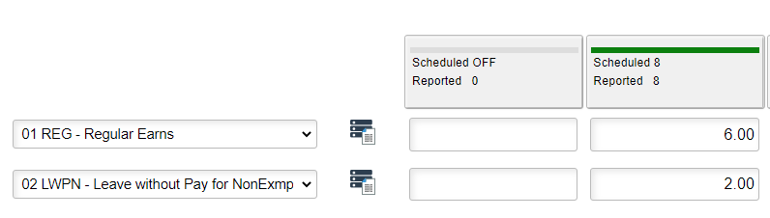

Example P: Two hours Leave without pay that is FMLA covered - clock reporter.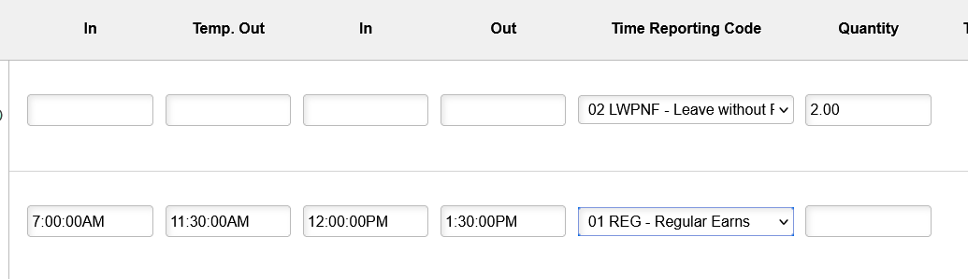

- The HR/Pay Time and Absence Information Guide will have a listing of all Time Reporting Codes: http://humanresources.ku.edu/sites/humanresources.drupal.ku.edu/files/docs/Time_and_Absence.pdf

- Below are some of the most common time reporting codes.
CM1 | Inclement Weather Position Designated – hour for hour - Only used for inclement weather declarations and only for Positions/Employees designated Weather/Emergency Essential
CME | Compensatory Time – employee has worked over 40 hours in a week or has holiday credit (HOLHR) and has worked hours which total over 40 hours in week. This should be approved if the employee work hours are correct.
HCP | Holiday Compensation -employee has reported time worked on the holiday and is to receive Holiday Compensation (the employee should also have the HOLHR in addition to this code). Employee reports as regular and Time Admin changes to holiday compensation. This is the KU most common practice.
HDP | Holiday Overtime Pay - employee has reported time worked on the holiday and is to receive additional 1.5 X their hourly rate in pay (the employee should also have the HOLHR in addition to this code). This must have prior budgetary approval.
HOLHR | Holiday Credit this should be approved if the employee is eligible for the Holiday.
REG | Regular - Actual hours worked for non-student employees.
SF | Shift hours -additional rate paid per hour based on employees’ regular required work schedule and clock times. Position/Employee Designated. Multiple Codes all start with SF.
SHREG | Regular – Actual hours worked for Student hourly employees.
ST1 | Standby Hours - pays a $1.00 per hour Position/Employee Designated
ST2 | Standby Hours - pays a $2.00 per hour Position/Employee Designated

